

Lab 1

[COMP6042_26213 Operating Systems in Practice](https://cit.instructure.com/courses/56613)

Student ID: R00201303

Date: 22.03.2022

Group: COMP1D-Y

Question1:

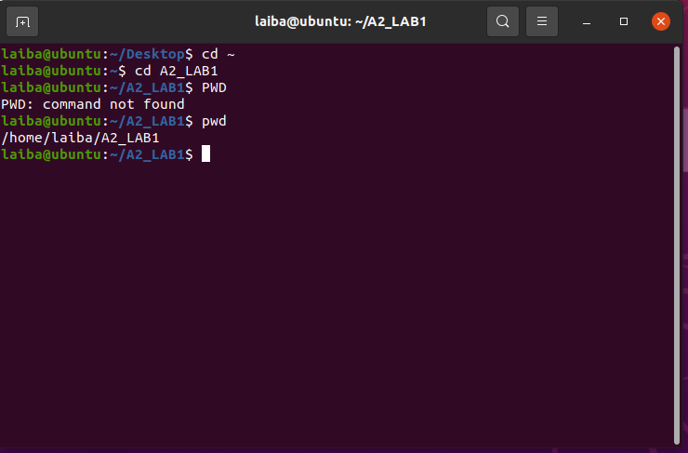

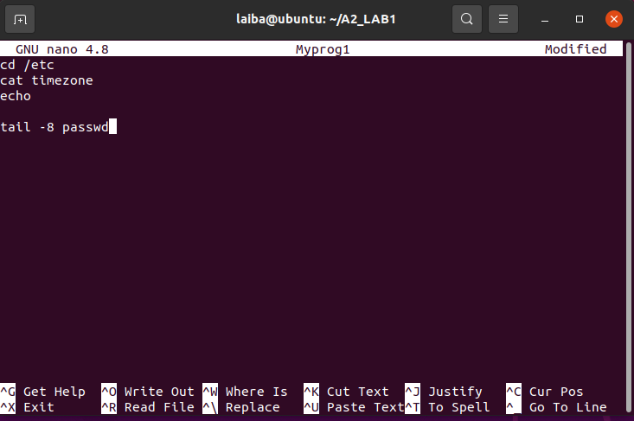

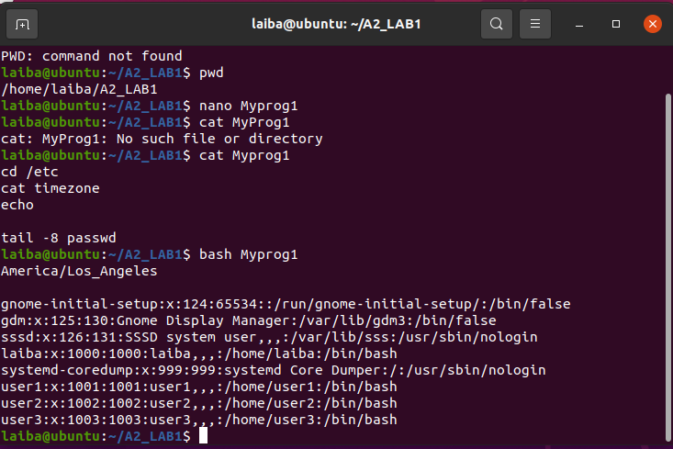

For your sample program, above, describe the impact of lines 1, 2, and 4:

Ans:

1: This command cd /etc changes directory to the directory specified after the slash / . The /etc refers to a folder in the root called etc .

2: To view your current timezone you cat the file's contents.

4: will show the tail of the file skipping 8 first lines.

Question2: 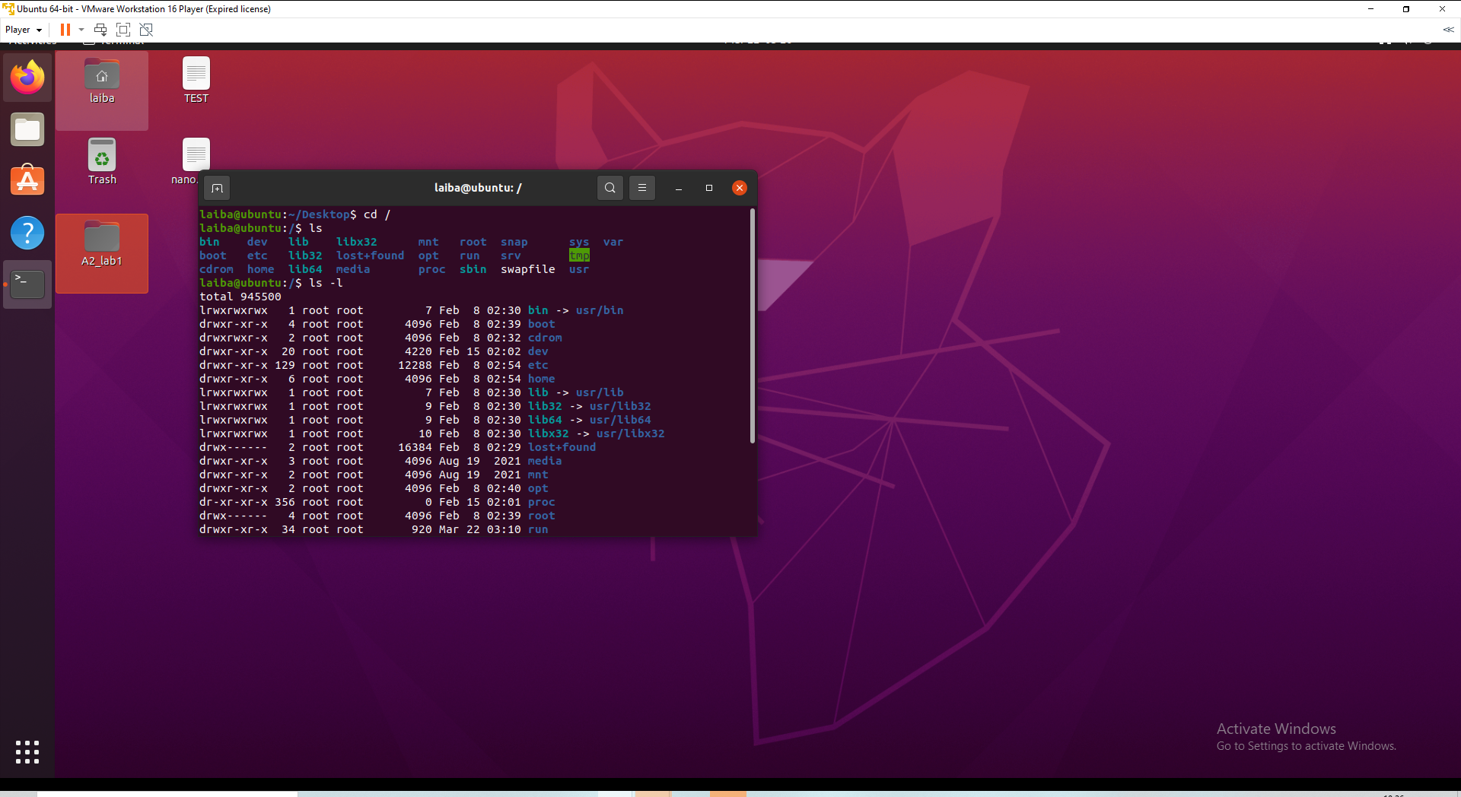

What is the purpose of the swapfile?

Ans: A swap file allows an operating system to mimic more memory by using hard drive space. When the system runs out of memory, it transfers a piece of RAM that is being used by an idle application onto the hard drive to make room for other processes. Ubuntu automatically creates a swap file of 2GB in size

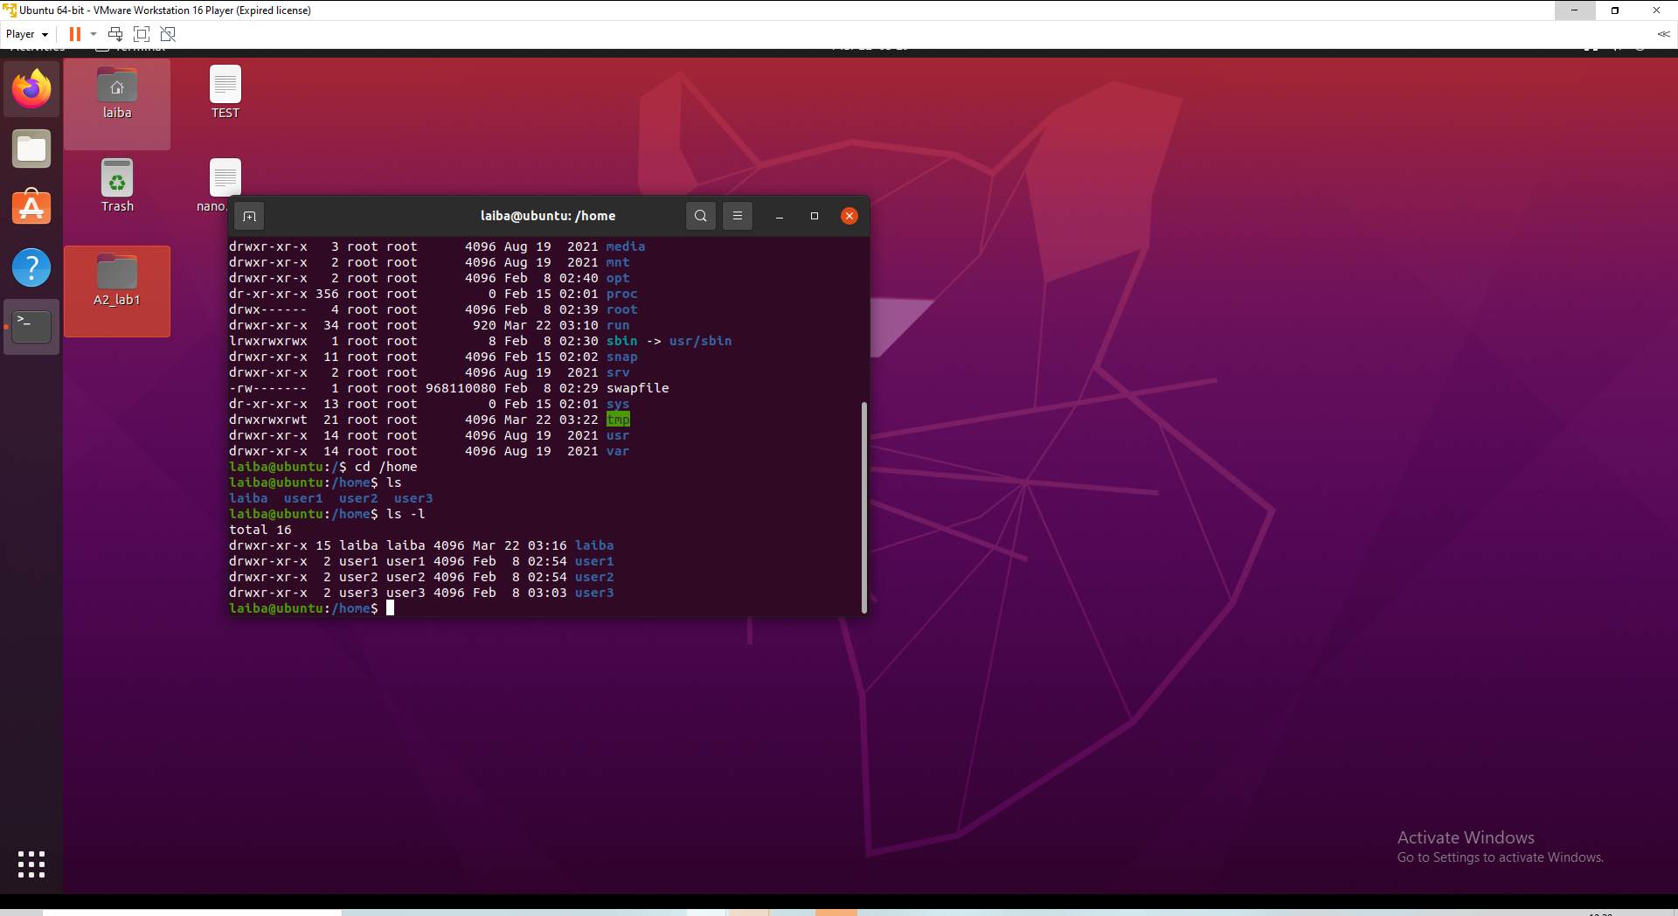

What is the purpose of this directory?

Ans: This is the location of your computer's desktop. Where can you keep your papers, photos, music, films, audio, and pretty much anything else? 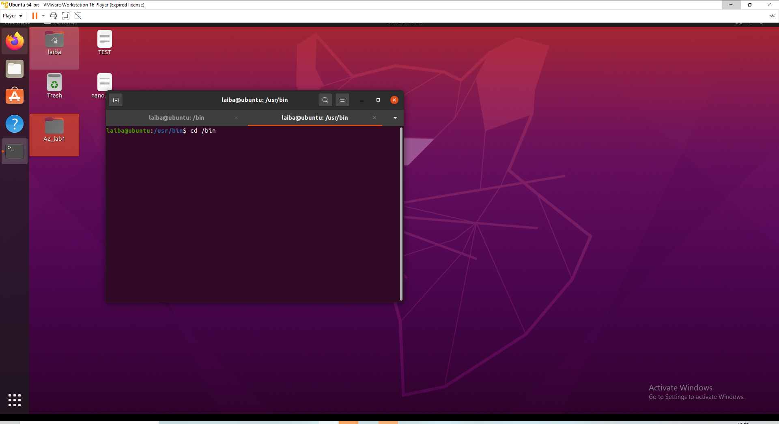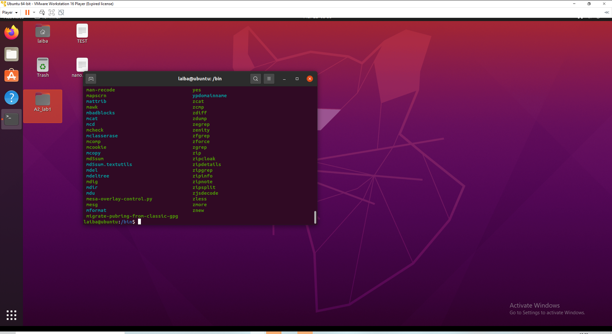 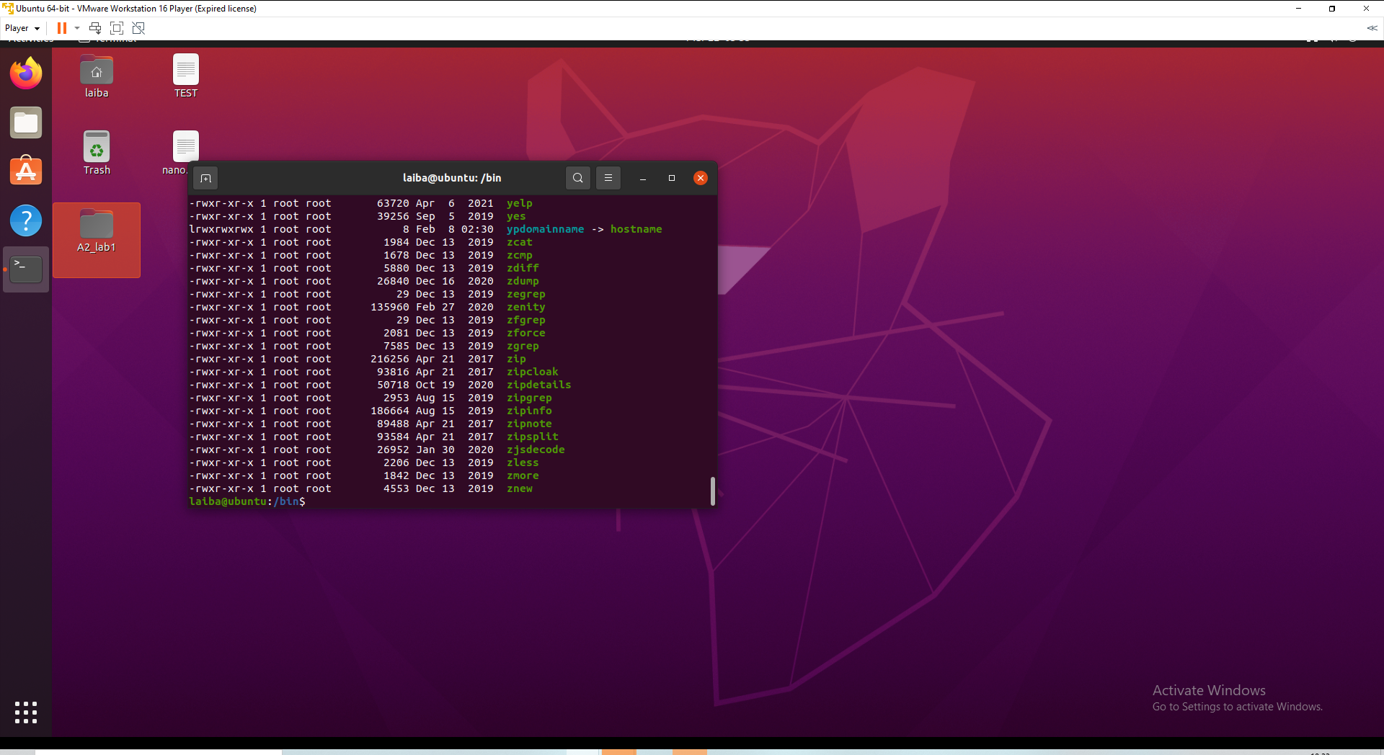What is the purpose of this directory?

Ans: includes the executable (ready-to-run) applications that must be accessible in order for a system to boot (i.e., start) and be repaired. 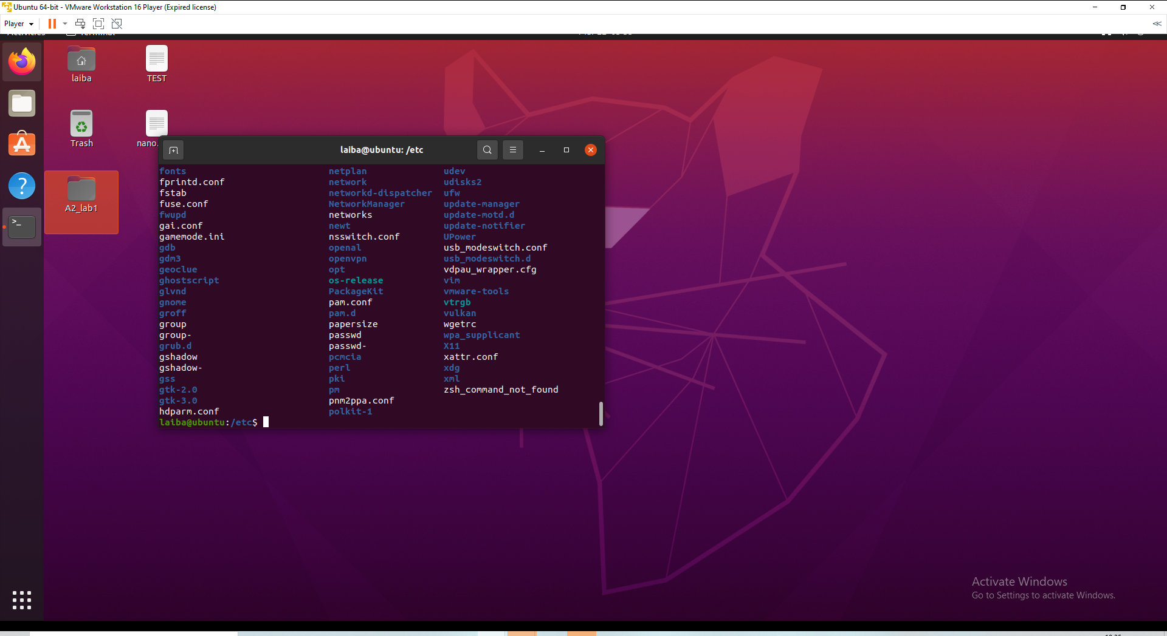 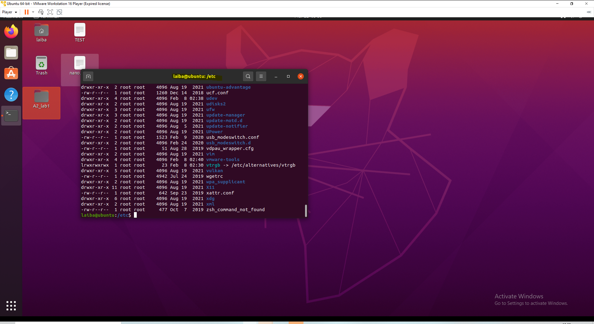What is the purpose of this directory?

Ans: Configuration files may be found in the /etc directory, which can usually be modified by hand with a text editor.

Question3:

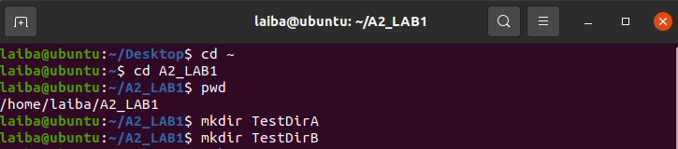

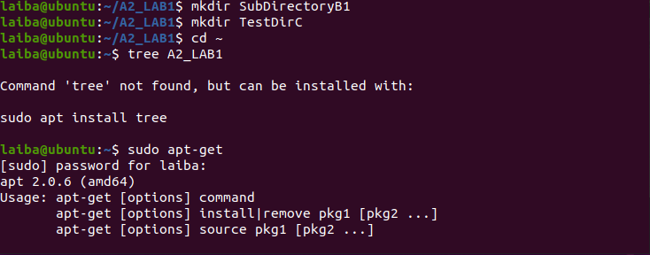

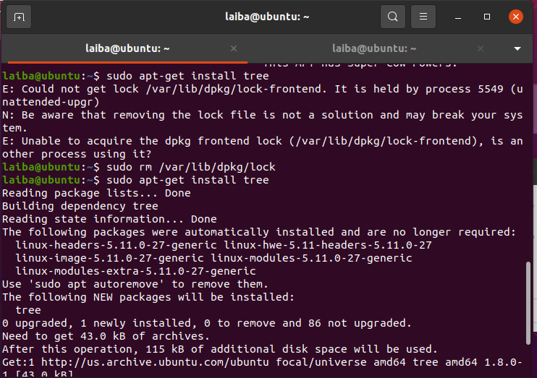

Question4: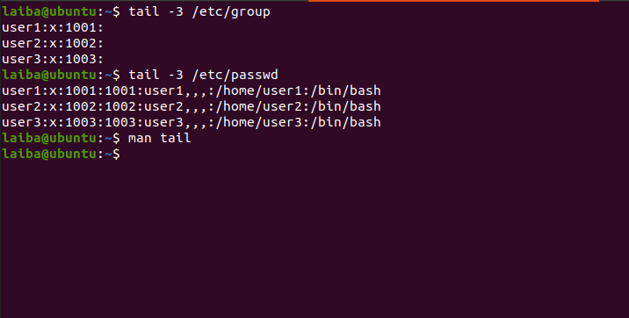Describe the functionality of the tail command:

Ans:

* Print the last 10 lines of each FILE to standard output. With more than one FILE, precede each with a header giving the file name.
* With no FILE, or when FILE is -, read standard input.
* Mandatory arguments to long options are mandatory for short options too.

What is the purpose of the group and passwd files?

Ans:

Group files: extra skills, such as access to disks, printers, and other peripherals, may be allocated in an orderly manner.

Passwd file: to keep track of every person who has been granted access to a system

Explain the fields of the last line of the group file:

Ans:

1. group-name : Contains the name assigned to the group.
2. group-password: Usually contains an asterisk or is empty.
3. gid: Contains the group's GID number.
4. user-list: Contains a comma-separated list of user names, representing the user's secondary group memberships.

Explain the fields of the last line of the passwd file:

Ans:

1. Username: It is used when user logs in.
2. Password: An x character indicates that encrypted password is stored in /etc/shadow file.
3. User ID (UID): Each user must be assigned a user ID (UID).
4. Group ID (GID): The primary group ID (stored in /etc/group file)
5. User ID Info (GECOS): The comment field.
6. Home directory: The absolute path to the directory the user will be in when they log in.
7. Command/shell: The absolute path of a command or shell (/bin/bash).

Question5:

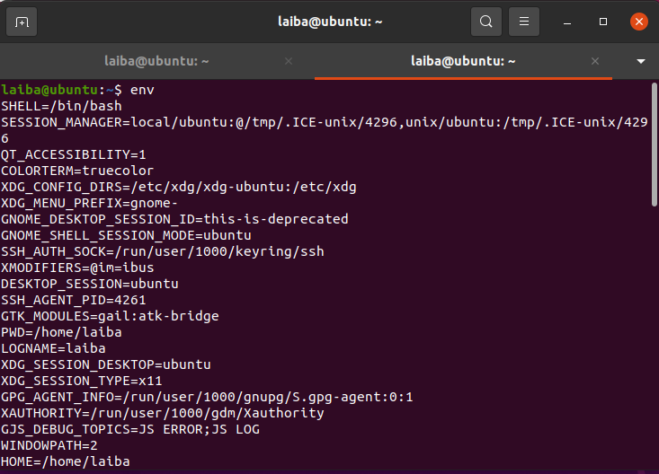

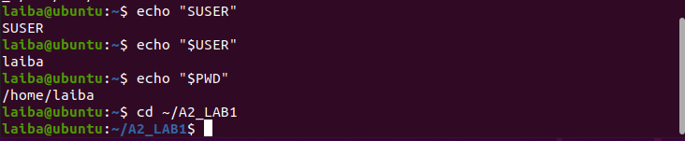

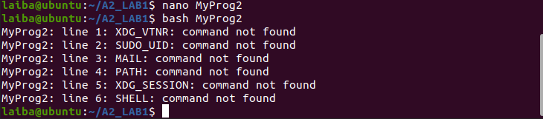 Describe each of the environment variables displayed by your program:

Ans:

1. XDG_VTNR: specifies the VT number.
2. SUDO_UID: Set to the uid of the user who invoked sudo.
3. MAIL: is a command-line utility that is used to send and manage the emails from the command line.
4. PATH: is an environmental variable that tells the shell and other programs which directories to search for executable files.
5. XDG_SESSION: is used to open a file or URL in the user's preferred application.
6. SHELL: provides an interface between the user and the kernel and executes programs called commands.

Question6:

Describe the |, > and >> operators in your own words:

Ans:

|: Binary OR Operator copies a bit if it exists in either operand.

The output (STDOUT) direction operators ">" and ">>" are both output (STDOUT) direction operators, however they differ in the following ways:

">" overwrites an existing file or creates a new one if the specified file name does not exist in the directory.

If the ">>" operator is used, it appends an existing file or creates a new one if the specified file name does not exist in the directory.

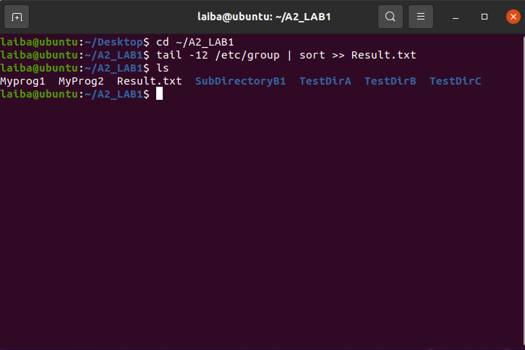

Explain, in your own words, what this command, Line 3 above, is doing. Show snippings to help your explanations:

Ans: Instead of ending at the end of the file, the tail command publishes the data starting from the provided line number. Data will begin printed from line number 'n' until the end of the file given by the command tail +n file name.